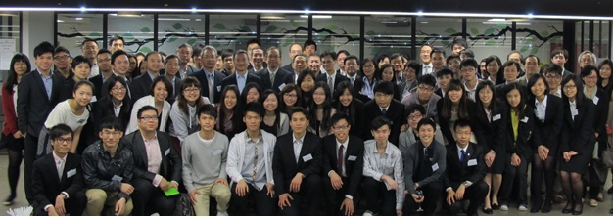
Relax, Reminisce & Reconnect with Us?
Join Our Alumni Reunion!
Alumni, staff, students, mentors, mentees, and guests
are all welcome
Thursday, 3rd April 2014
6:00 – 8:00 pm
At our Studio, 5/F
Knowles Building, HKU
Drinks and finger food will be served
HK$100 per head
RSVP (see next page)
An AGM will be held at the same time
Organized by the HKU Surveying Alumni Association

Supporting organizations:
Dept. of Real Estate & Construction, HKU
Surveying Society, HKU
HKU Surveying Alumni Association

Registration Form for the Alumni Reunion

<Deadline for registration: 1st April 2014>

I / We want to reserve __________ places at HK$100 each for the Alumni Reunion organized by the HKU Surveying Alumni Association on 3rd April 2014 (Thursday) 6:00 p.m. – 8:00 p.m. at the Studio, 5/F, Knowles Building, HKU.
Name of participant | Degree & year of graduation/study | Phone no.

I/We hereby deposit the amount with HONG KONG AND SHANGHAI BANKING CORPORATION LIMITED BANK (HSBC) A/C No. 469-126635-001 and A/C Name “The University of Hong Kong Surveying Alumni Association” or send a cheque payable to “The University of Hong Kong Surveying Alumni Association”.
Please send this form together with the pay-in slip or cheque to us by 1st April 2014 through:
1. Fax: (852) 2559 9457 (for pay-in slip only) or
2. Post:
The University of Hong Kong Surveying Alumni Association
c/o Department of Real Estate and Construction,
The University of Hong Kong, Pokfulam Road, Hong Kong.

For enquiries, please contact us at 2219 4377 or surveyaa@hkucc.hku.hk.

